**Amar Gajanan Mohite**

Section – IFT562

**Arizona State University**

Instructor**:** Daniel Wells

**Activity 9- Working with AWS CloudTrail**

Date – 03/03/2024

At the end of Task 2.1, take a screenshot showing the created CloudTrail.  Make sure your logged in user account is visible in the top right corner.

At the end of Task 3.4, enter your full name into the command prompt and take a screenshot of the terminal.

aws s3 cp s3://monitoring7777/ . --recursive

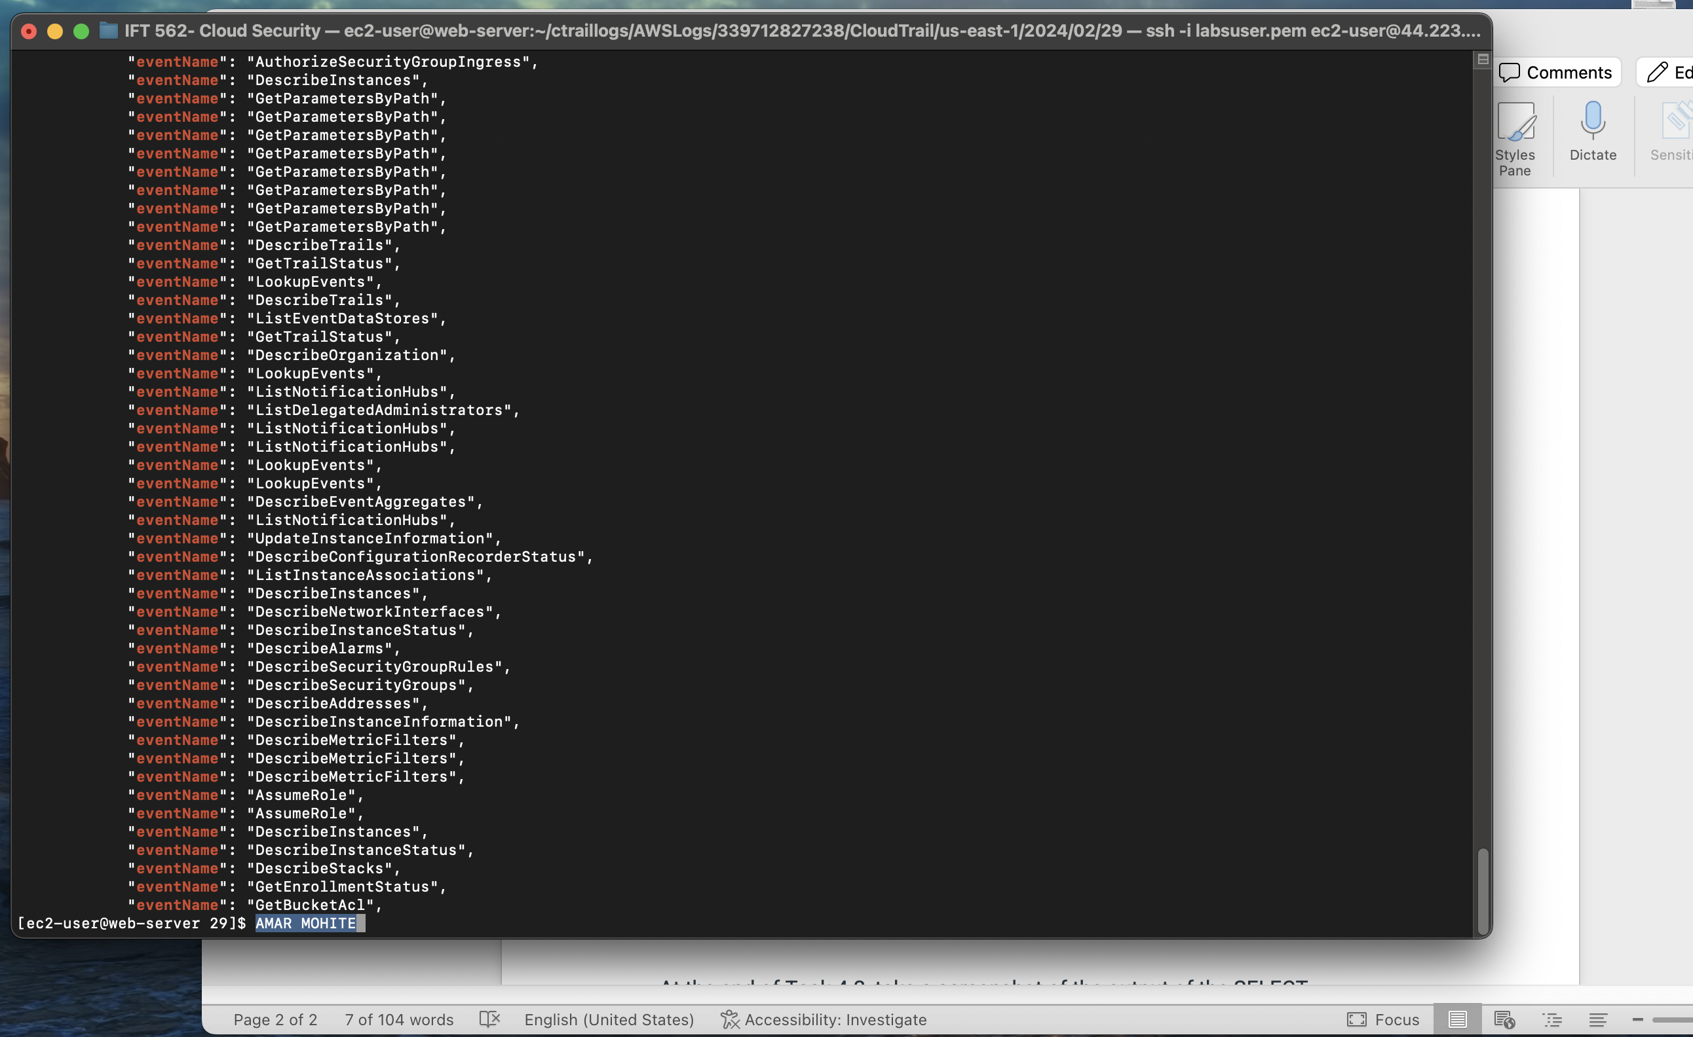

At the end of Task 4.2, take a screenshot of the output of the SELECT statement.  Make sure your logged in user account is visible in the top right corner.

